Example 1: Halifax, NS (I circled the humidity and cloud coverage fields)

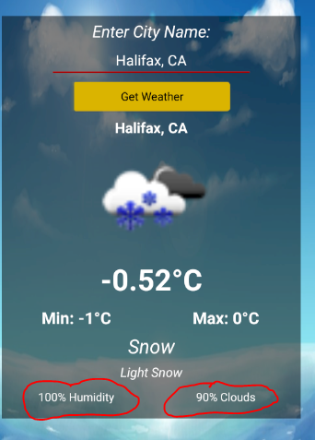

Example 2: Toronto, ON

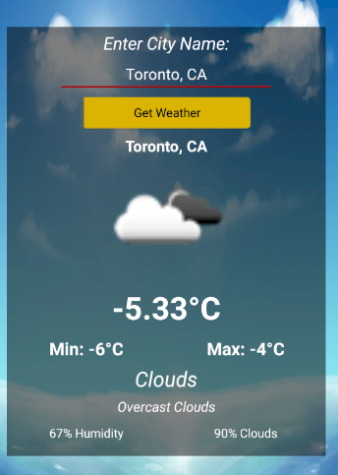

Example 3: Orlando, FL

